Directions for running Agilent 6850 GCs and ChemStation software

To start the computer:
The GCs stay on in shutdown mode. Turn the computer on by pushing the button in middle of front panel of computer. Click on the instrument online icon. To work with existing data or to explore the ChemStation software, you can choose the offline icons.

There are 3 sections of the chem station software: Method and Run Control, Data Analysis, and Report Layout. These can be accessed through the View menu on the top toolbar, or from a scroll-down window in the upper left.

To set the GC conditions:
From Method & Run Control, load desired method (such as Split_LP.M or FAME.M) and make any desired changes in parameters from Instrument/Edit parameters on top toolbar. The most likely thing to change are the oven settings. The temperature should go from about the lowest boiling point of any component to the highest boiling point in the mixture.
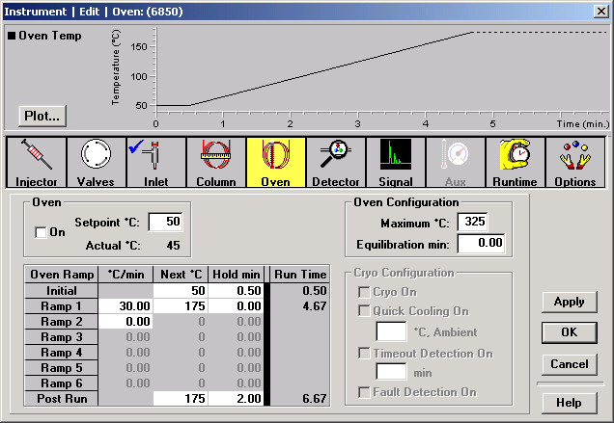
Making the Post Run temperature high has the advantage of flushing out the column. Making the Post Run temperature the same is the initial temperature has the advantage of not needing Prep Run for each sample (see below.)

To shutdown for the day:
•From View/Method & Run Control, load SHUTDOWN.M on both GCs.
•Close all open windows
•From the lower left of screen, choose my computer, shutdown, standby

For each sample:
There are 3 sections of the ChemStation software: Method and Run Control, Data Analysis, and Report Layout. These can be accessed through the View menu on the top toolbar, or from a scroll-down window in the upper left. Go to Method and Run Control.
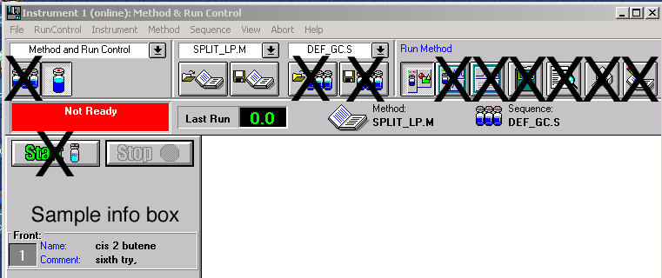
•Click on sample info box in the middle left of screen. Enter operator name, filename (if no new file name is entered, the previous data file will be overwritten), sample name, sample amount (injection volume), comment (put oven temperature information here). Click on OK.
•When sample info has been entered and the red Not Ready box has changed to a green Ready box in the upper left corner of screen, press the PREP RUN button on GC. (This latter step is unnecessary of the final temperature of the method is the same as the initial temperature.) The instrument will say not ready for a second, then the green ready light will come on again.
•Quickly and carefully inject a dilute sample (0.2-1.0 µL ) and press the START button on the GC. You might need to use menu View/online signals/signal window 1 in order to see the live chromatogram.
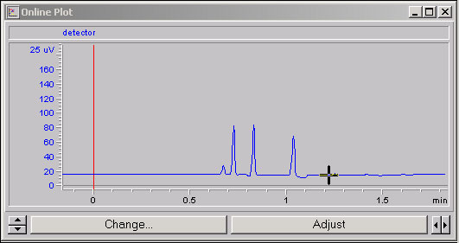
Click on the scroll arrows to change vertical or horizontal scale .
Click on Adjust to reset baseline (you may have to do this several times.)
•At the end of the run, or after you have pressed the button in the upper left screen. Go to menu View/Data Analysis. Use the X button to click with the arrow on the solvent peak to remove it from the area calculations.
Go to View/Report Layout. You want BASIC.FRP as the report template. Click the preview button in upper right of the report layout screen, and then click on print next to it. | Preview Print

